

**END 3952**

**SUPPLY CHAIN MANAGEMENT**

**by**

**UMUT RIFAT TUZKAYA**

**Subject** : Vehicle Routing Problem

**Prepared By** : Barış Karakum 15061010

Oğuzhan Cingöz 14061506

Mustafa Kaleli 16069002

Savaş Kaymak 15061014

**CONTENTS**

**ABSTRACT**………………………………….……………………………………III

**CHAPTER 1:** **TYPES OF VEHICLE ROTE PROBLEMS**

1.1 CVRP (Capacitated Vehicle Routing Problem) 4

1.2. Distance-Constrained Capacitated Vehicle Routing Problem (DCVRP) 4

1.3 Multi-Depot Vehicle Routing Problem (MDVRP) 4

1.4 Split Delivery VRP (SDVRP)…………………………………………………… 4

1.5 Time Dependent VRP (TDVRP) ………………………………………………… 4

1.6 VRP with heterogeneous fleet (VRPHE) ………………………………………… 4

1.7 VRP with Pick Up and Delivery (VRPPD) ……………………………………… 5

1.8 VRP with time windows (VRPTW) ……………………………………………… 5

**CHAPTER 2:** **MATHEMATICAL MODELS FOR VRP**

**CHAPTER 3:** **SOLUTION TECHNIQUES**

3.1 Heuristics 7

3.1.1 Construction heuristics 8

3.1.2 Decomposition and partitioning heuristics 8

3.2 METAHEURISTICS FOR THE VRP 9

3.2.1 Evolutionary Computing (Genetic Algorithms), GA 10

3.2.2 Simulated Annealing, SA 11

3.2.3 Tabu Search, TS 11

**CONCLUSION AND REFERENCES**………………...…………………………………...12

**ABSTRACT**

In this study we discuss the Vehicle Routing Problem with multiple use of vehicles (VRPM). In this variant of the routing problem the vehicles may replenish at any time at the depot. We present a detailed review of existing literature and propose two mathematical models to solve the VRPM. For these two models and their several variants we provide computational results based on the test problems taken from the literature. We also discuss a case study in which we are simultaneously dealing with side constraints such as time windows, working hour limits, backhaul customers and a heterogeneous vehicle fleet.

**Keywords**: Vehicle Routing, Set-Covering, Heuristics, Metaheuristics for the VRP, Heterogeneous Vehicle Fleet

III

## 1.TYPES OF VEHICLE ROTE PROBLEMS

* 1. **CVRP (Capacitated Vehicle Routing Problem):**

It takes into account the vehicle capacity. The nodes are assigned specific demands. Baldacci and Mingozzi (2004), Baldacci, Toth and Vigo (2010) solved the problem using exact algorithms.

* 1. **Distance-Constrained Capacitated Vehicle Routing Problem (DCVRP):**

For each route, capacity restriction is replaced by a maximum length or by a time constraint. Kara (2010, 2011) presented integer programming formulations.

* 1. **Multi-Depot Vehicle Routing Problem (MDVRP):**

In this variant several depots are considered to serve clients. Clients are usually assigned to depots using clustering strategies. Some solution techniques have been used in this problem for exampleRenaud et al (1996), Salhi and Sari (1997) solved the problem with heuristics.; Ombuki-Berman and Hanhar (2009) with Genetic Algorithms (). Vidal et al. (2014) presented a new state of the art results for MDVRP and multi-depot vehicle fleet mix problems (MDVFMP) with unconstrained fleet size.

* 1. **Split Delivery VRP (SDVRP):**

Each customer is required to be visited by exactly one vehicle and the objective is to minimize the total distance traveled. The restriction that each customer has to be visited exactly once is removed, split deliveries are allowed. Archetti, Savelsbergh and Speranza (2006) presented a survey of the state-of-the-art. Wilck IV and Cavalier (2012)have posed a construction heuristic.

* 1. **Time Dependent VRP (TDVRP):**

Travel time between two customers or between a client and the deposit depends on the distance between the points and the time of day is considered. Malandraki and Daskin (1992) presented a state of-the-art; Donati et al. (2008) used ACO to solve the problem.

* 1. **VRP with heterogeneous fleet (VRPHE):**

Fleet of vehicles of different capacities. Sometimes considered or not fixed costs and / or variables in the fleet. Lima, Goldbarg and Goldbarg (2004) presented a memetic algorithm to solve the problem. (). The problem considering time windows was solved by Paraskevopoulos et al. (2008). Kwon, Choi and Lee (2013) solved the problem considering carbon emissions.

* 1. **VRP with Pick Up and Delivery (VRPPD):**

Is defined over a net. Where some nodes represent delivery customers who expect deliveries from a depot, and other nodes represent pickup customers who have available supply to be picked up and transported to a depot Nagy and Salhi (2003) proposed different algorithms for solving the problem. The most cited article is Chen and Wu (2006) in this work the problem was solved using hybrid heuristics. Subramian et al. (2010) proposed a parallel heuristic.VRP with time deadlines (VRPTD): In this problem, the travel times are not fixed but rather depend both on the distance between two vertices and the time of the day (e.g., it takes longer to get from one location to another during rush hours). The contribution of this variant is more closely modeling situations observed in the real world. Thangiah, Vinayagamoorty and Gubbi (1993) solved the problem with genetic and local algorithm; Özyurt, Aksen and Aras (20065) performed a state of the art of VRPTD.

* 1. **VRP with time windows (VRPTW):**

The aim is to serve all customers in a defined time interval. Solomon (1987) presented solutions, methods and applications. In Solomon (1987) the design and analysis of algorithms for vehicle routing and scheduling problems was considered with time window constraints. In this work were found several heuristics with performed well in different variants of VRP. Bräysy and Gendreau (2005) presented a complete review of metaheuristics applied to the problem. Lau, Sim and Teo (2003) proposed Tabu search by a holding list and a mechanism to force dense packing within a route.

## 

## 2. MATHEMATICAL MODELS FOR VRP

### 

***MATHEMATICAL MODELS VRP*** can be modeled in different forms. Such as Vehicle Flow Formulations (VFF), Commodity Flow Formulations (CFF) and Set Partitioning Formulation (SPF). These basic models can be modified to reach a specific VRP. VFF: This formulation is weak in the presence of a hard constraints model. It is useful when you must perform assignments of vehicles to routes. The number of variables is polynomial and number of constraints is exponential.

A Set of arcs

V Set of vertices

S Set of clients cij non negative cost

K Number of vehicles available

Xij Binary variable activated if the arc i, j is used.

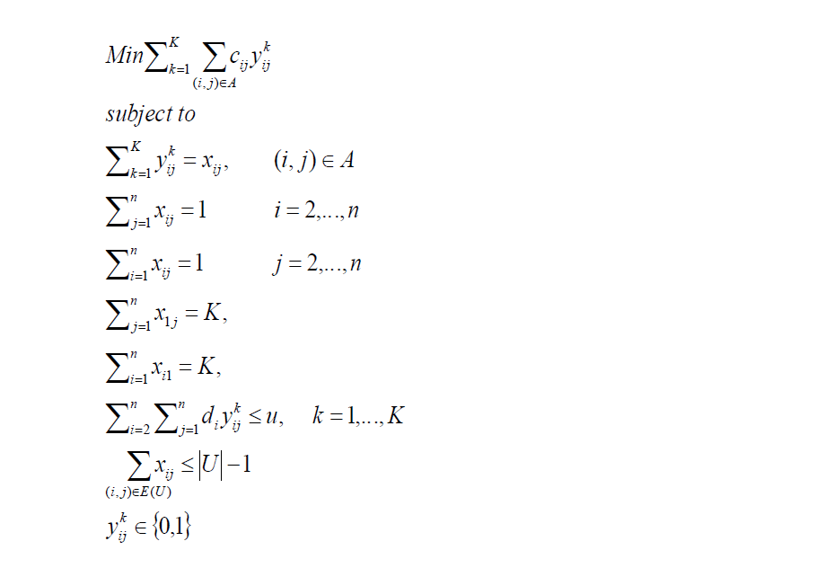

**3. SOLUTION TECHNIQUES**

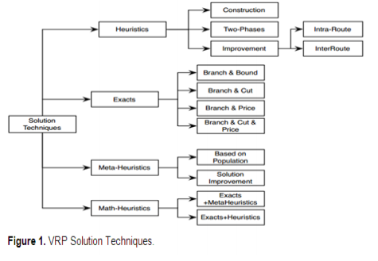

Exact techniques The VRP in its different forms, was initially addressed using exact techniques such as Branch and Bound algorithm proposed by Laporte and Nobert (1987); Fischetti, Toth and Vigo (1994) and Baldacci and Mingozzi (2004), Branch and Cut considered by Cordeau (2006), Branch and Price was posed byPessoa et al., 2008; Martinelli et al., 2011,and Branch and Cut and Price proposed by Baldacci et al.,( 2010). 5.2.

**3.1 Heuristics**

Heuristic approach cannot guarantee optimal solutions, but their goal is to nd a "good" solution in reasonable time. Not all of the heuristics discussed were originally designed to solve the VRP, but were modied for this purpose.

In this section we will discuss some of the heuristic methods that are proposed in the literature to solve the VRP. According to Zanakis et al. (1989) who thoroughly scanned the literature (442 papers in 37 journals) for the use of dierent conventional heuristic methods, we can roughly make the following classication. However, we will not discuss all twelve classes mentioned in their paper. We only discuss the classes that according to us have proved to be of signicant importance for solving the VRP and its extensions:

*1. Construction heuristics*

*2. Decomposition and partitioning heuristics*

Now we will give an example of a heuristic for each of these classes and discuss its properties. Note that for a good solution approach a sequential use of several heuristics might be necessary in order to obtain satisfactory solutions. For example, constructive heuristics are frequently used to and initial feasible solutions which then can be improved using one or more improvement heuristics.

**3.1.1 Construction heuristics**

This class of heuristics gradually constructs solutions by adding nodes or arcs to the solution following a predened set of rules. The famous nearest neighbor heuristic that was originally developed for the TSP, can also be used for solving the VRP. The heuristic works as follows. Let S be the set of all customers that are not routed yet. We randomly pick a customer as the starting point of our tour. Then we look in S for the closest node to the starting point. We add this customer to our route and remove it from S. We continue till S = ∅ and connect the last added node with the starting point and we obtain a Hamiltonian cycle. It tends to perform well in the beginning, but while adding the last customers to the tour, some expensive arcs have to be used. Even though it is highly unlikely to nd the optimal solution in this way, it is possible to nd a reasonable solution in polynomial time.

To modify this heuristic for the VRP, we simply add the rule that every time a vehicle is full we end the tour and start a new tour from the depot (starting point of the tour). Note that we select the node for insertion by the rule of nearest neighbor of the last inserted note. We could modify this rule into: cheapest insertion, farthest insertion, random insertion, etc.

Another important heuristic based on a constructional principle is the saving heuristic introduced by Clarke and Wright (1964). This heuristic starts with n tours that all serve a single customer. Then the cost that can be saved by merging route i and j for each pair i, j are dened as sij .

Here ci0 is the cost between node i and node 0 (the depot). We merge the routes with the highest savings, given that the capacity restrictions are satised and merging is applied to the nodes next to the depot in each route. We continue till no further savings can be obtained. Computational results of dierent methods are presented by Laporte and Semet (2001), see Table 2.1, given at the end of this chapter.

**3.1.2 Decomposition and partitioning heuristics**

This class includes both decomposition and partitioning heuristics as the dierence is sometimes hard to expound. Decomposition heuristics solve a sequence of smaller sub-problems; the output of the previous sub-problem is used as the input for the next. Partition heuristics are quite similar as they also partition the original problem and solve these sub-problems independently from each other. Some examples of this class of heuristics are,

1. Cluster first, route second heuristic

2. Route first, cluster second heuristic

3. Petal heuristic

The cluster-rst, route-second heuristic rst makes up a set of rules to divide the customer set in several clusters. The goal of this rst phase is to nd m clusters of entire customer set, each of which is a disjoint set from others, and with equally distributed demand between the clusters. In the second phase a TSP is solved for each cluster individually.

The route-rst, cluster second heuristic is doing the exact same steps, but in reverse order. First we try to nd a giant tour by solving the TSP problem for all customers. Second we try to nd an optimal partition of this tour to obtain feasible vehicle routes in terms of capacity and time limitations. Beasley (1983) is the rst source to apply this idea to the VRP. He proposes several modications of this approach to obtain good quality solutions for the classical VRP.

The Sweep Heuristic is a modication of a route-rst, cluster second heuristic. It was rst discussed by Gillett and Miller (1974). The idea is based on the following assumptions. We assume that all nodes have known coordinates on a plane and the distances are Euclidean. Then we calculate for each customer the polar coordinate angle with respect to the depot and order them in terms of these angles. After reordering we start assigning customers to vehicles in such a way that we start with the rst customer on the list and keep adding customers to the route while keeping the route feasible. Once this is no longer possible, we nish the route and start a new route.

The last, but probably the most interesting heuristic of this class is an algorithm rst discussed by Foster and Ryan (1976) in an attempt to employ the fact that many optimal solutions show a petal or an almost petal structure. In this approach the authors start similar as in the sweep method by assigning polar coordinate angles and reorder all customers accordingly. In the next step they list all feasible routes with a petal structure. In the last step they solve a linear program to optimality in which they select a set of feasible petal routes (a spanning petal) such that each customer is visited and the total traveled distance is minimized. A major advantage for this method is that additional constraints can easily be added, but the drawback is the CPU time.

This method has proved to give near optimal results for several problems with size ranging from 21 to 100 customers. In the year this paper was written these were good results. However to further improve this promising method, Ryan et al. (1993) propose an alternative method to nd the optimal petal solution. This method is based on a shortest path technique. The authors rst dene a cyclic petal directed graph where the nodes correspond to customers and the arcs to generalized petals. In this they dene a generalized petal as the petals obtained when reordering the customers in a non-radial cyclic order before generating the petals. Then they claim that the problem reduces to nding a shortest path on this cyclic petal directed graph. Computational results of dierent methods are presented by Laporte and Semet (2001), see Table 2.1, given at the end of this chapter.

**3.2 Metaheuristics for the VRP**

The latest development in solving combinatorial optimization problems is the use of Metaheuristics. Where conventional approximation methods are no longer su cient, metaheuristics can be very helpful. They have been developed since early 1980's. Osman and Laporte (1996) dene a metaheuristic as an iterative generation process which guides a subordinate heuristic by combining intelligently dierent concepts for exploring and exploiting the search space. Learning strategies are used to structure information in order to nd e ciently near-optimal solutions. An important property is that in most metaheuristics we allow nonimproving and infeasible solutions as intermediate steps to avoid local optima. Some classes of metaheuristics are :

*1. Constrained logic programming, CLP*

*2. Evolutionary Computing (Genetic Algorithms), GA*

*3. Neural Networks, NN*

*4. Simulated Annealing, SA*

*5. Tabu Search, TS*

*6. Nonmonotonic search trajectories*

*7. Threshold algorithms*

*8. Hybrid methods*

Not all of these methods have (frequently) been used to solve the VRP. Therefore we will only discuss four of these classes of metaheuristic in this paper. Based on the frequency that these methods are applied to the VRP, we will discuss: GA, SA and TS. We note that metaheuristics frequently make use of conventional heuristics to nd good starting points of the search trajectory.

**3.2.1 Evolutionary Computing (Genetic Algorithms), GA**

The principles of Genetic Algorithms are based on the fact that we maintain a population of solutions by an iterative reproduction process. In each step we select "parent" solutions to produce so called "ospring" solutions with some features of every parent. The quality of each ospring solution is measured by the objective function value. In general the number of ospring solutions that survive, i.e. the solutions with the best objective function values, is equal to the number of parent solutions chosen in order to keep the population size at the same level.

The question how a parent solution can represent a VRP solution is not straightforward. Baker and Ayechew (2003) choose for a representation of size n with values in the range of [1, m] that represent which vehicle visits each customer. Note that for this representation the total distance traveled is not immediately known, but by solving m TSP's the optimal objective function for every solution can be obtained. A dierent representation could be a string of size n + m with values in the range of [0, n] that are ordered in the way the customers are visited. Each time a new vehicle is used, we separate this by adding a zero in the string. This way it is not necessary to solve m TSP's at each iteration. See Figure 2.1 for two dierent representations of the same VRP solution.

Also for creating ospring solutions there does not exist a clear set of rules that is to be used. Depending on the problem structure we can create ospring solutions by cross-over, randomness, etc. Computational results are scarce, but Baker and Ayechew (2003) claim that the GA is performing good, although it is beaten by TS in terms of solution quality. However, when they make some small adjustment (hybrid GA) they nd solutions almost similar to the best known solutions. More often than the classical VRP, the GA has been used to solve the VRP with time windows.

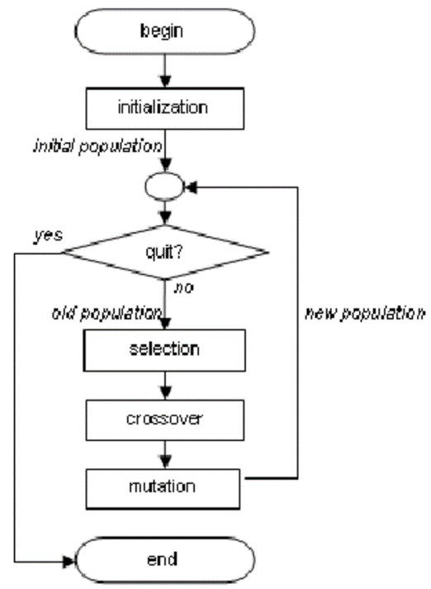

**3.2.2 Simulated Annealing, SA**

Simulated Annealing (SA) starts from an initial solution and at each iteration a solution in neighborhood of previous solution is selected. When an improvement is found we continue with this solution and redene neighborhood as such, however when a worse solution is picked we continue with this solution with probability pt where t is the iteration counter. The probability that a worse solution is picked will usually diminish over time, because when approaching the global optimum we would like to avoid decreasing steps.

Osman (1993) reports a successful implementation of SA for VRP. He uses a λ-interchange generation mechanism to determine neighborhood of a given solution. First two routes are selected and then we choose a subset of customers from each route such that the size of these sets is less than or equal to λ. When the interchange of these subsets is feasible in terms of capacity, the move is feasible. Note that the subsets of customers are allowed to be empty and therefore "donation" is also included in this method. Donation means that a customer is moved to a dierent route without returning another customer. Computational results show several good results for problem instances ranging in size from 30 to 200 customers.

**3.2.3** **Tabu Search (TS**)

Tabu Search works similar as SA, we also start with an initial solution and then search neighborhood of this solution. However, in TS we are always looking for the best solution in neighborhood which is then used as our next solution. To avoid cycling we put the "old" solutions in a Tabu-list. Members from this list cannot be selected anymore. TS has been proven to be very eective when solving the VRP. Osman (1993) and Taillard (1993) have reported high quality solutions for most of the instances from the VRP-library for both symmetric and asymmetric cases. CPU-times are very high compared to conventional heuristics, but still acceptable. For instances up to 200 customers, both authors report CPU-times of sometimes close to 100 minutes.

Another metaheuristic solution methods examples are:

• Firefly Algorithm

• Artificial Bee Colony Algorithm

• Ant Colony Algorithm

• Particle Swarm Optimization Algorithm

**CONCLUSION**

**REFERENCES**